Factor 09: Disposability

1. 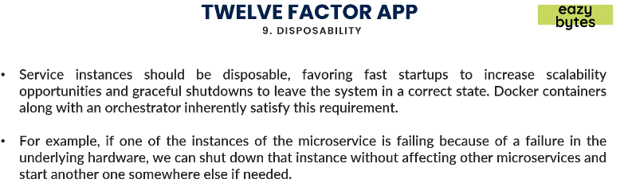
2. As per this factor, the service instances should be disposable.
3. Whenever we need to scale up, we should be able to run different new instances of a microservice fast enough and same with when scaling down.

Factor 10: Dev/Prod Parity

1. All environments must look similar to one another as much as possible.  
   You should not do any configurations when moving from one environment to another environment like creating environmental variables or creating a class path folder location, creating a folder location or creating a FTP folder location.  
   If you’re doing such configurations in different environments, you’re slowing down the deployment process of a microservice.
2. So, all environments should work in the similar manner.

Factor 07: Port Binding

1. 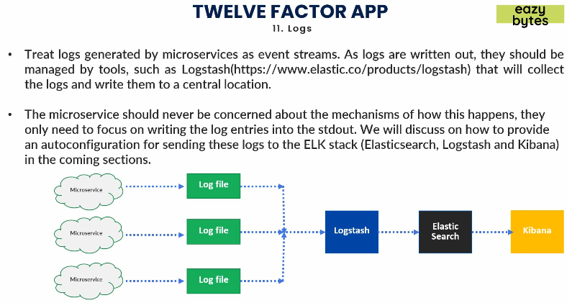
2. The amount of logs you can image that maybe generated from hundred of microservices.
3. All the logs should be maintained in a central location so that we can search them and do analysis on them.
4. So each microservice should push these logs as an event and then it should forget about it.
5. **ELK**: Common approach to maintain logs in microservice environment.
   1. Log Stash: Would maintain log files.
   2. Elasticsearch: To index.
   3. Kibana: Graphical Representation of those logs.

12: Admin Processes

1. 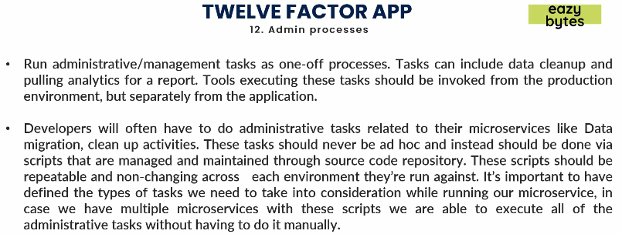
2. Every app not only cloud native app has some admin processes.

So with this we discussed all the 12 factors/principles we need to follow for a successful Cloud Native App.  
